DATA PROTECTION USING HYBRID ENCRYPTION AND STEGANOGRAPHY
Conclusion, Future Scope and References
Department of Computer Science and Engineering, TKR College of Engineering & Technology
Batch A15 (CSE-A) · Academic year [ACADEMIC YEAR]
Table 1: Project team
S.No. | Student name | Roll number
1 | Allam Rakesh | 23K91A0509
2 | Bolleddu Shanker | 23K91A0543
3 | Agaram Sri Sarvagna | 23K91A0506
4 | B Akshay | 24K915A0504

Project guide: Rajalakshmi
Chapter and section numbers quoted in the text (for example Chapter 8 or Section 6.2) refer to the full project report, 17.Final Document. Figures and tables in this document are numbered from 1.

1. CONCLUSION

1.1 Summary of the work
CipherVeil was built to show a two-layer protection for a confidential file: encryption that survives discovery of the payload, and hiding that does not announce that a secret is moving. A file is encrypted with a fresh AES-256-GCM key, the key is wrapped with the receiver's RSA public key, and the resulting bundle is written into the least significant bits of a PNG. The receiver extracts the bundle, unwraps the key, verifies the tag and the file hash, and obtains the original file. The work is grounded in the base paper [1], whose LSB carrier and key-exchange framing it adopts, and not its homomorphic computation.
The system was evaluated and not only demonstrated. Over 22 runs on six covers the file was restored byte for byte every time, PSNR was at least 52.479 dB (mean 61.731 dB), SSIM at least 0.995806, and capacity was 3.0 bits per pixel. A closed-form model reproduced measured PSNR within 0.053 dB, and the same measurement at full capacity gave 51.14-51.17 dB.

1.2 Objectives achieved
Table 2: The six objectives and their status
Objective | Status | Headline evidence
AES for the payload, RSA for the AES key | Achieved | AES-256-GCM + RSA-OAEP-SHA256; 240 of 240 tamper trials rejected
Key generation and exchange | Achieved for the keypair workflow | 2048, 3072, 4096-bit keys, PEM import and export; no identity check
Embed by LSB | Achieved | 1 bit per colour value, 3.0 bits per pixel, capacity check
Extraction and decryption | Achieved | 22 of 22 byte-exact restorations
PSNR and SSIM | Achieved | PSNR 52.479-74.615 dB up to 73 % fill, 51.14 dB at 100 %; SSIM at least 0.9929
Capacity, time and robustness | Measured | 86 ms median unwrap; lossless handling only survives; detectable at medium and high fill

1.3 Key findings
1. Encryption costs nothing in image quality. Plain and encrypted payloads flip about 50 % of the embedded bits either way, so PSNR depends only on how many bits are embedded; encryption makes the stream balanced and unreadable.
2. Imperceptibility is predictable. PSNR follows 10 log10(255^2 / (0.5 n / N)) within 0.053 dB, and never falls below 51.1 dB even at full capacity.
3. The scheme is robust to lossless handling only. Of 18 attacks, 5 were survived; JPEG at quality 100 already loses the payload, and the error rate of 49-50 % leaves nothing for a correcting code to repair.
4. Hidden is not undetectable. The chi-square test flagged all 30 embedded prefixes and the weighted-stego estimate followed the fill, because embedding is sequential and key-independent.
5. The cryptographic layer is cheap and strict. AES-GCM takes 0.15 ms; the RSA unwrap (94 ms at 3072 bits) dominates; any single-bit change is rejected before data is released.

1.4 Practical applications
• Sending a small confidential file (a few kilobytes to a few hundred kilobytes) as an ordinary-looking PNG over a channel that does not recompress images.
• A teaching tool that shows PSNR, SSIM, histograms and bit planes for real data, and what lossy processing does to a hidden payload.

1.5 Known limitations
The payload is lost to any lossy change and the images can be flagged statistically; the private keys are unencrypted at rest; there is no sender authentication; the evaluation uses six covers and four small synthetic payloads on one machine. These are listed with their evidence in Chapters 8 and 10.

1.6 Lessons learned
• A closed-form model is worth deriving: it turned PSNR from a result into a check.
• Perceptual quality is the wrong proxy for security; the chi-square test found the data in images with PSNR above 57 dB.
• Measure the whole request: the cryptography took 0.15 ms and a send took 438 ms because of PNG encoding and SSIM.

1.7 Concluding remarks
CipherVeil delivers a working, tested, double-layer protection tool whose strengths and weaknesses are both measured. The honest reading is a sound hybrid encryption layer with a simple hiding layer on top: the content is protected by standard cryptography, the concealment is good to the eye and weak to statistics, and the image must stay a PNG.
The results behind the key findings are shown below: the measured PSNR against the closed-form value at every fill level, and how the measured range sits next to the PSNR values reported in a supporting paper (different covers and payloads, so indicative only).
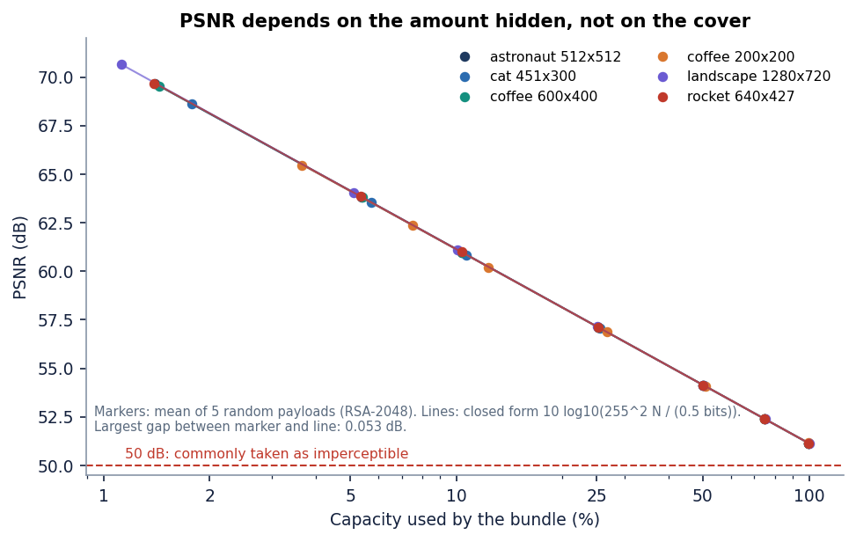
Figure 1: Measured PSNR against the closed-form model for six covers at seven fill levels (mean of five payload seeds).
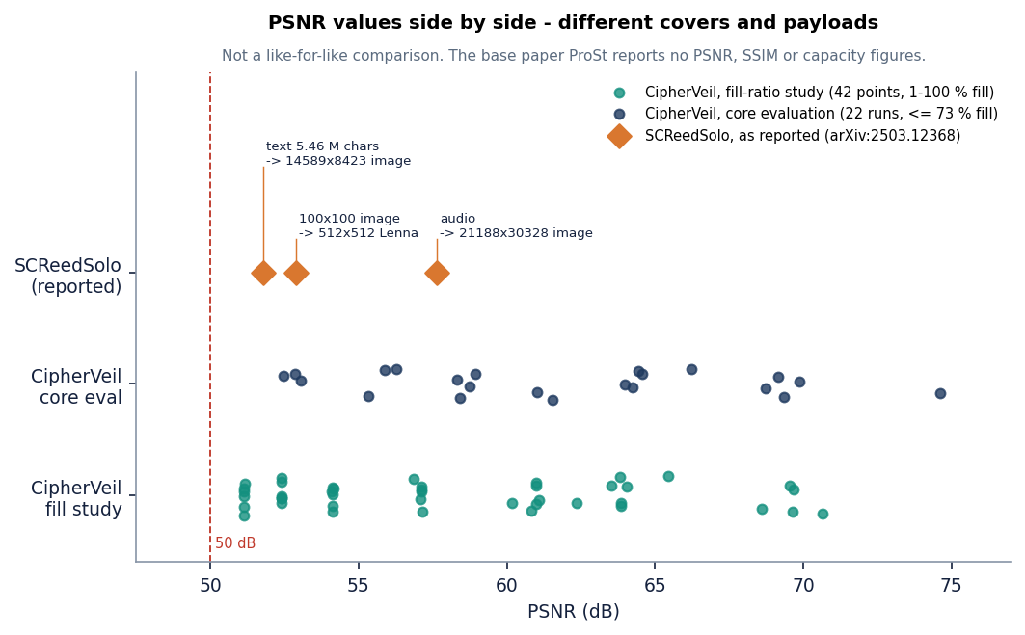
Figure 2: PSNR measured here next to the values reported by SCReedSolo; covers and payloads differ and the base paper reports no PSNR, so this is indicative only.

2. FUTURE SCOPE

2.1 Improvements to the existing system
1. Key-dependent pixel selection. Derive a pseudo-random permutation of the embedding positions from a shared secret (or from the session key) so that the payload is no longer in raster order; this moves towards the location secrecy of the base paper and defeats the oracle chi-square test on the prefix.
2. LSB matching and adaptive embedding. Replace LSB replacement by +/-1 matching [12] and by cost-based embedding with syndrome-trellis codes [13], which change fewer values and avoid the pair-equalisation signature of replacement.
3. Error correction. Add Reed-Solomon coding, as in SCReedSolo [3], so that mild bit corruption can be repaired; JPEG itself would still need transform-domain embedding.
4. Sender signatures. Sign the bundle with Ed25519 or RSA-PSS so that the receiver learns who sent it and a message cannot be forged by anyone who holds the public key.
5. An encrypted key store. Protect private keys at rest with a passphrase-derived key (scrypt or Argon2) or an operating-system store, and add rate limiting and a generated JWT_SECRET.

2.2 Additional features
• Compression before encryption to increase the effective capacity, and a choice of fill levels with a warning when the estimated detectability is high.
• Post-quantum key transport: a KEM such as ML-KEM next to or instead of RSA-OAEP.
• More carriers: audio (WAV) and video frames, and JPEG-domain embedding for channels that recompress.
• Multiple recipients: wrap the same session key for several public keys in one bundle.
• Fix the empty-key crash on the Send page and add an assertion-based browser test suite.

2.3 Scalability and deployment
• Move the quality measures (SSIM, PNG encoding) off the request path, since they cost about 300 ms of each send and cryptography costs 0.15 ms.
• Replace SQLite by a server database with row-level ownership, store the stego images in object storage and add a job queue for large covers.
• Package the backend and the console as containers and serve both behind TLS; the demonstration runs as two local processes.

2.4 Further research
• Evaluate against stronger steganalysis (sample-pair, RS, rich-model and deep detectors) at several fill levels, and report detection error against fill as the base paper's security view would require.
• Bring the base paper's secret-position idea into the pipeline: hide the payload bits among decoys with a keyed location generator and measure the capacity cost of the added security.
• Run a formal usability study with real senders and receivers, including how they move PNG files through ordinary channels.
• Measure on a larger corpus of camera photographs, including previously compressed images.

3. REFERENCES
[1] S. Ahmad and S. Rass, "ProSt: Provably secure homomorphic steganography," IEEE Access, vol. 14, pp. 14393-14409, 2026, doi: 10.1109/ACCESS.2026.3656995.
[2] S. E. Fatemieh, R. Shahdi Alizadeh, and E. Zarezadeh, "Design of memristive lightweight encryption for in-memory image steganography," arXiv:2605.03494, May 2026.
[3] S. R. Raiyan and M. H. Kabir, "SCReedSolo: A secure and robust LSB image steganography framework with randomized symmetric encryption and Reed-Solomon coding," arXiv:2503.12368, 2025 (ACPR 2025).
[4] B. Kukreja and S. Malik, "An steganography-based triple layered image data hiding using visual cryptography," 2024 (authors as listed on the Authorea preprint page; venue and year of formal publication not confirmed).
[5] "Steganography - data hiding using image object," Gurukul International Multidisciplinary Research Journal, 2024.
[6] "Hybrid steganography: Leveraging chaotic encryption and CNN for robust image hiding," in Proc. 7th Int. Conf. Mechatronics, Robotics and Automation (ICMRA), 2024.
[7] "Enhanced image steganography with AES encryption and hybrid DWT-DCT transform for secure data hiding," International Journal of Advanced Research, 2025.
[8] J. Fridrich, Steganography in Digital Media: Principles, Algorithms, and Applications. Cambridge, U.K.: Cambridge Univ. Press, 2009.
[9] I. J. Cox, M. L. Miller, J. A. Bloom, J. Fridrich, and T. Kalker, Digital Watermarking and Steganography, 2nd ed. Burlington, MA, USA: Morgan Kaufmann, 2008.
[10] N. Provos and P. Honeyman, "Hide and seek: An introduction to steganography," IEEE Security & Privacy, vol. 1, no. 3, pp. 32-44, May/Jun. 2003.
[11] C.-K. Chan and L. M. Cheng, "Hiding data in images by simple LSB substitution," Pattern Recognition, vol. 37, no. 3, pp. 469-474, Mar. 2004.
[12] J. Mielikainen, "LSB matching revisited," IEEE Signal Processing Letters, vol. 13, no. 5, pp. 285-287, May 2006.
[13] T. Filler, J. Judas, and J. Fridrich, "Minimizing additive distortion in steganography using syndrome-trellis codes," IEEE Trans. Information Forensics and Security, vol. 6, no. 3, pp. 920-935, Sep. 2011.
[14] C. Cachin, "An information-theoretic model for steganography," in Information Hiding (IH 1998), Lecture Notes in Computer Science, vol. 1525. Berlin, Germany: Springer, 1998, pp. 306-318.
[15] A. Westfeld and A. Pfitzmann, "Attacks on steganographic systems," in Information Hiding (IH 1999), Lecture Notes in Computer Science, vol. 1768. Berlin, Germany: Springer, 2000, pp. 61-76.
[16] J. Fridrich, M. Goljan, and R. Du, "Detecting LSB steganography in color and gray-scale images," IEEE MultiMedia, vol. 8, no. 4, pp. 22-28, Oct.-Dec. 2001.
[17] S. Dumitrescu, X. Wu, and Z. Wang, "Detection of LSB steganography via sample pair analysis," IEEE Trans. Signal Processing, vol. 51, no. 7, pp. 1995-2007, Jul. 2003.
[18] J. Fridrich and M. Goljan, "On estimation of secret message length in LSB steganography in spatial domain," in Proc. SPIE, vol. 5306, Security, Steganography, and Watermarking of Multimedia Contents VI, 2004, pp. 23-34.
[19] A. D. Ker and R. Bohme, "Revisiting weighted stego-image steganalysis," in Proc. SPIE, vol. 6819, Security, Forensics, Steganography, and Watermarking of Multimedia Contents X, 2008, Art. no. 681905.
[20] Advanced Encryption Standard (AES), Federal Information Processing Standards Publication 197, NIST, Nov. 2001.
[21] M. Dworkin, "Recommendation for block cipher modes of operation: Galois/Counter Mode (GCM) and GMAC," NIST Special Publication 800-38D, Nov. 2007.
[22] R. L. Rivest, A. Shamir, and L. Adleman, "A method for obtaining digital signatures and public-key cryptosystems," Communications of the ACM, vol. 21, no. 2, pp. 120-126, Feb. 1978.
[23] K. Moriarty, B. Kaliski, J. Jonsson, and A. Rusch, "PKCS #1: RSA cryptography specifications version 2.2," IETF RFC 8017, Nov. 2016.
[24] M. Bellare and P. Rogaway, "Optimal asymmetric encryption," in Advances in Cryptology - EUROCRYPT '94, Lecture Notes in Computer Science, vol. 950. Berlin, Germany: Springer, 1995, pp. 92-111.
[25] J. Katz and Y. Lindell, Introduction to Modern Cryptography, 2nd ed. Boca Raton, FL, USA: Chapman & Hall/CRC, 2014.
[26] Z. Wang, A. C. Bovik, H. R. Sheikh, and E. P. Simoncelli, "Image quality assessment: From error visibility to structural similarity," IEEE Trans. Image Processing, vol. 13, no. 4, pp. 600-612, Apr. 2004.
[27] Q. Huynh-Thu and M. Ghanbari, "Scope of validity of PSNR in image/video quality assessment," Electronics Letters, vol. 44, no. 13, pp. 800-801, Jun. 2008.
[28] C. Gentry, "Fully homomorphic encryption using ideal lattices," in Proc. 41st ACM Symp. Theory of Computing (STOC), 2009, pp. 169-178.
[29] V. Costan and S. Devadas, "Intel SGX explained," IACR Cryptology ePrint Archive, Report 2016/086, 2016.

